**Bill Discount :**

**Test Data Creation :**

**ADH Home Subscription :**

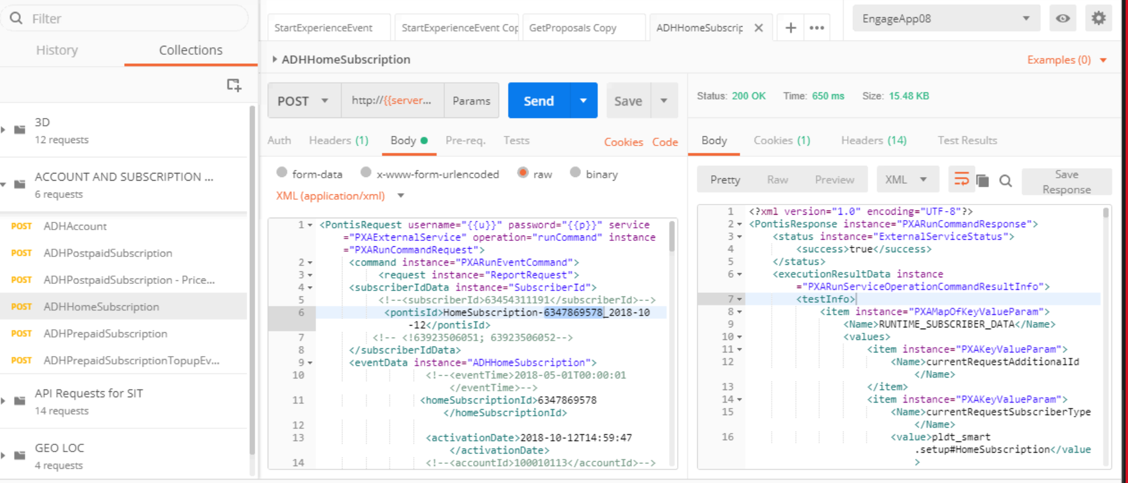

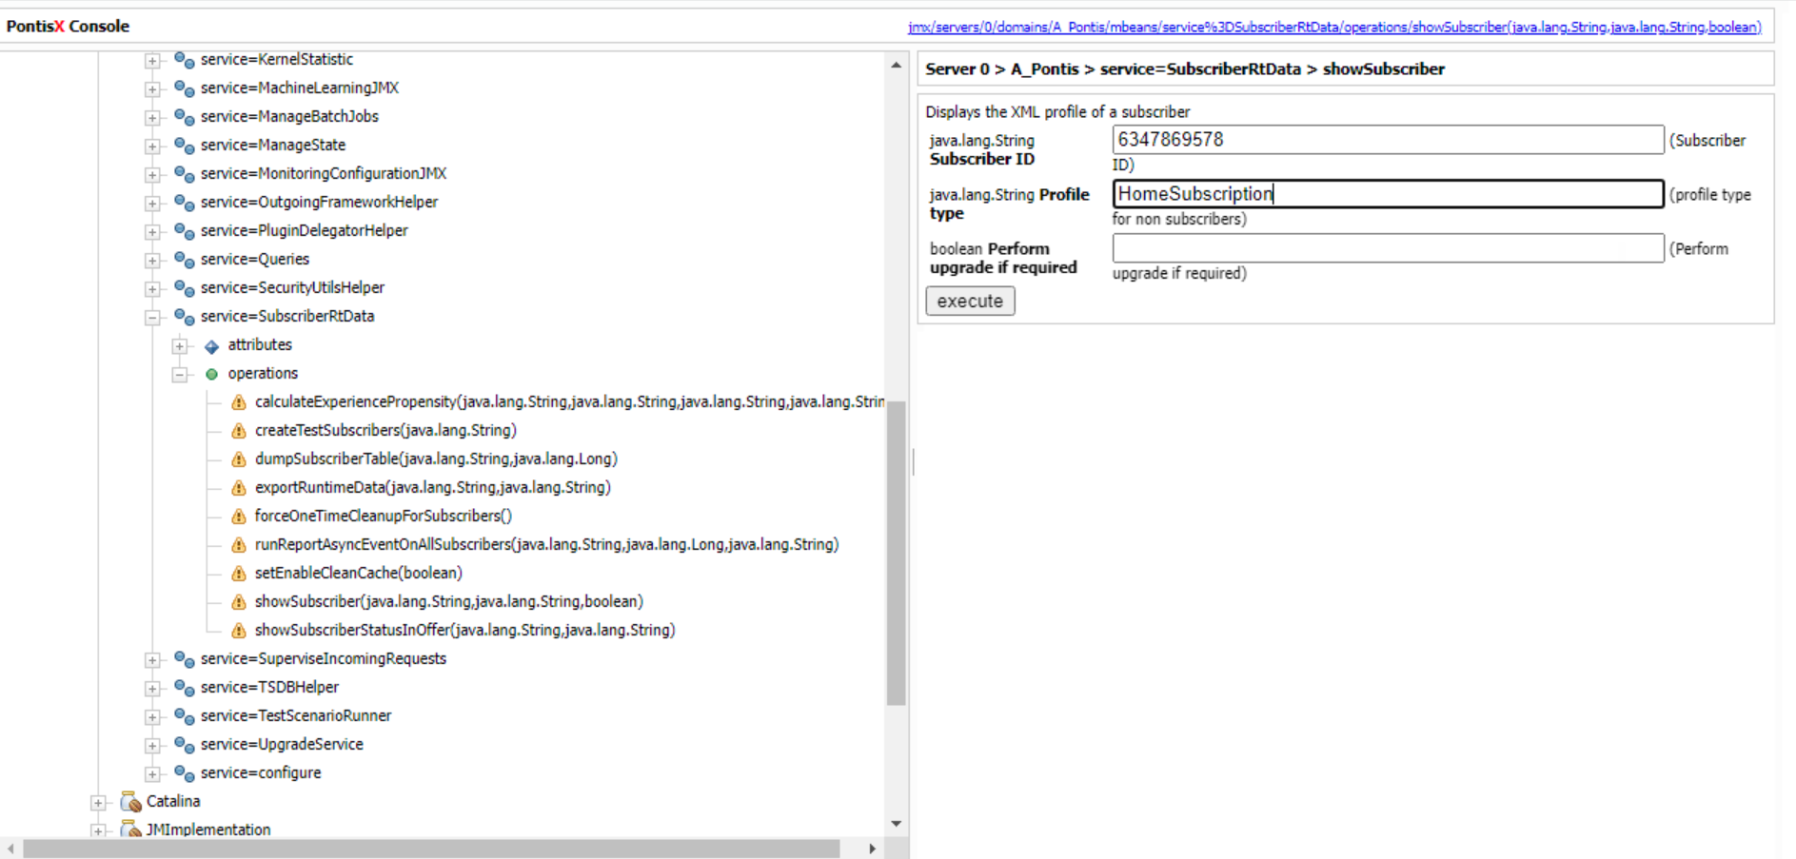

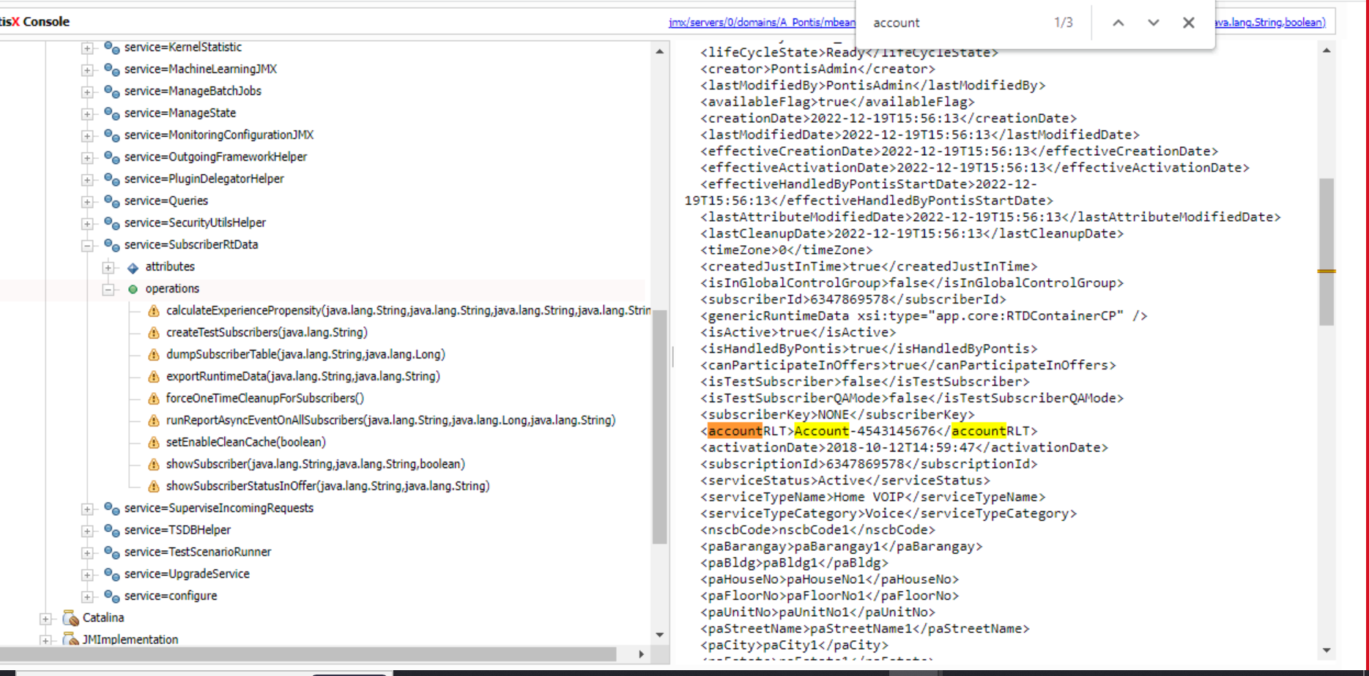

**ADH Account :**

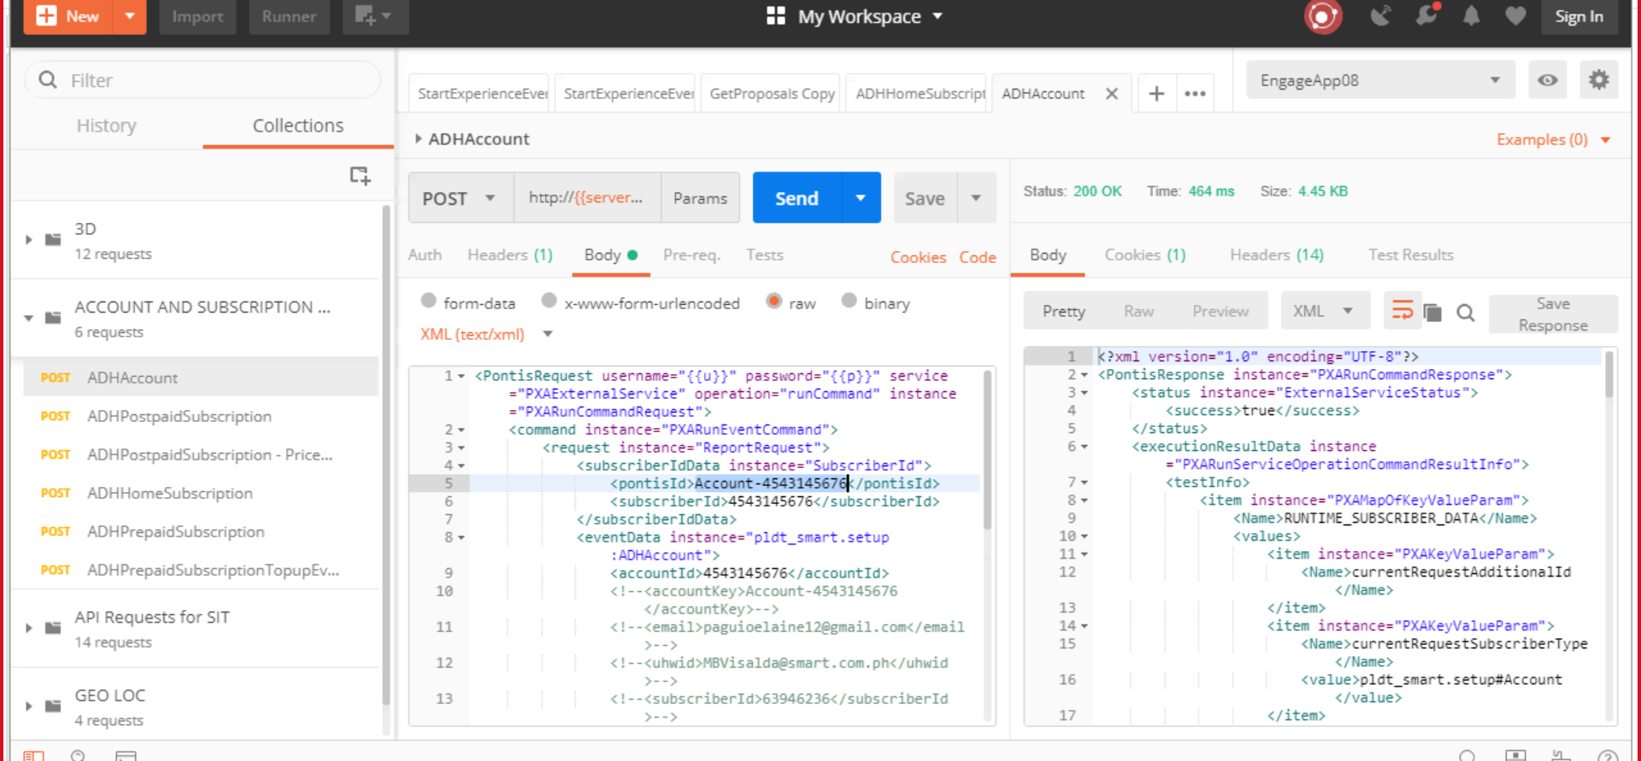

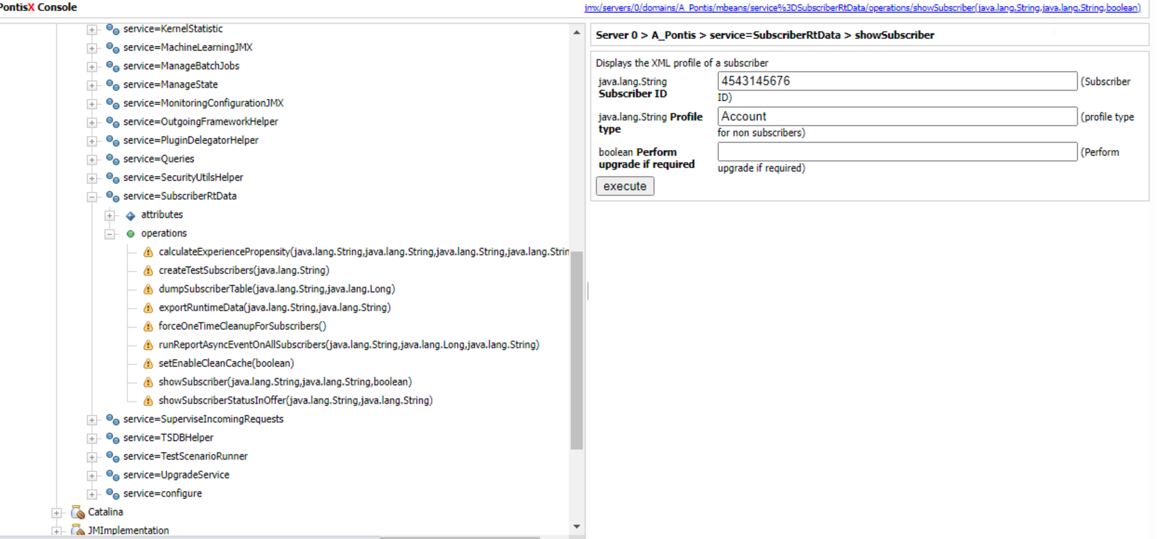

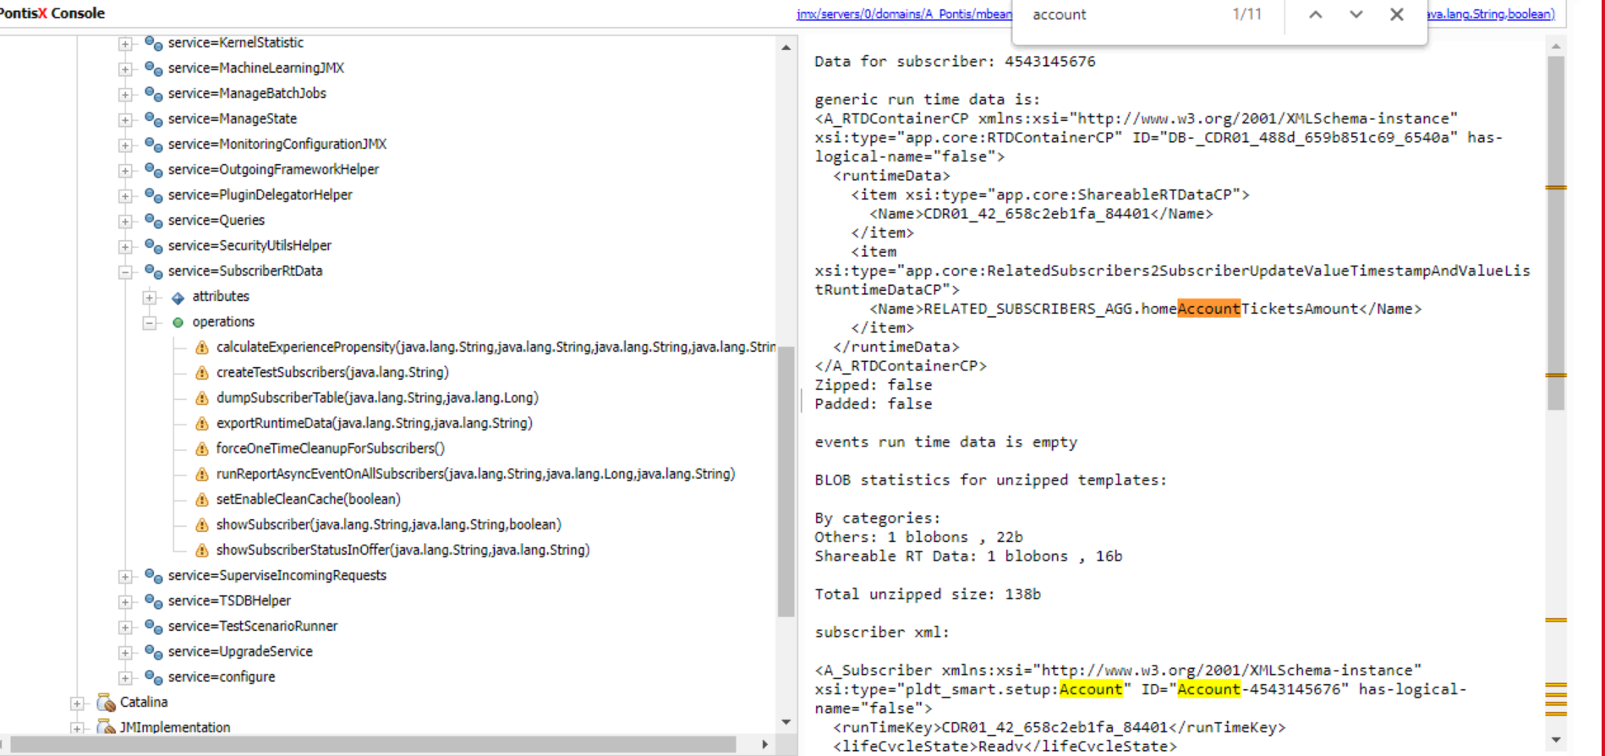

**TC 001 :**

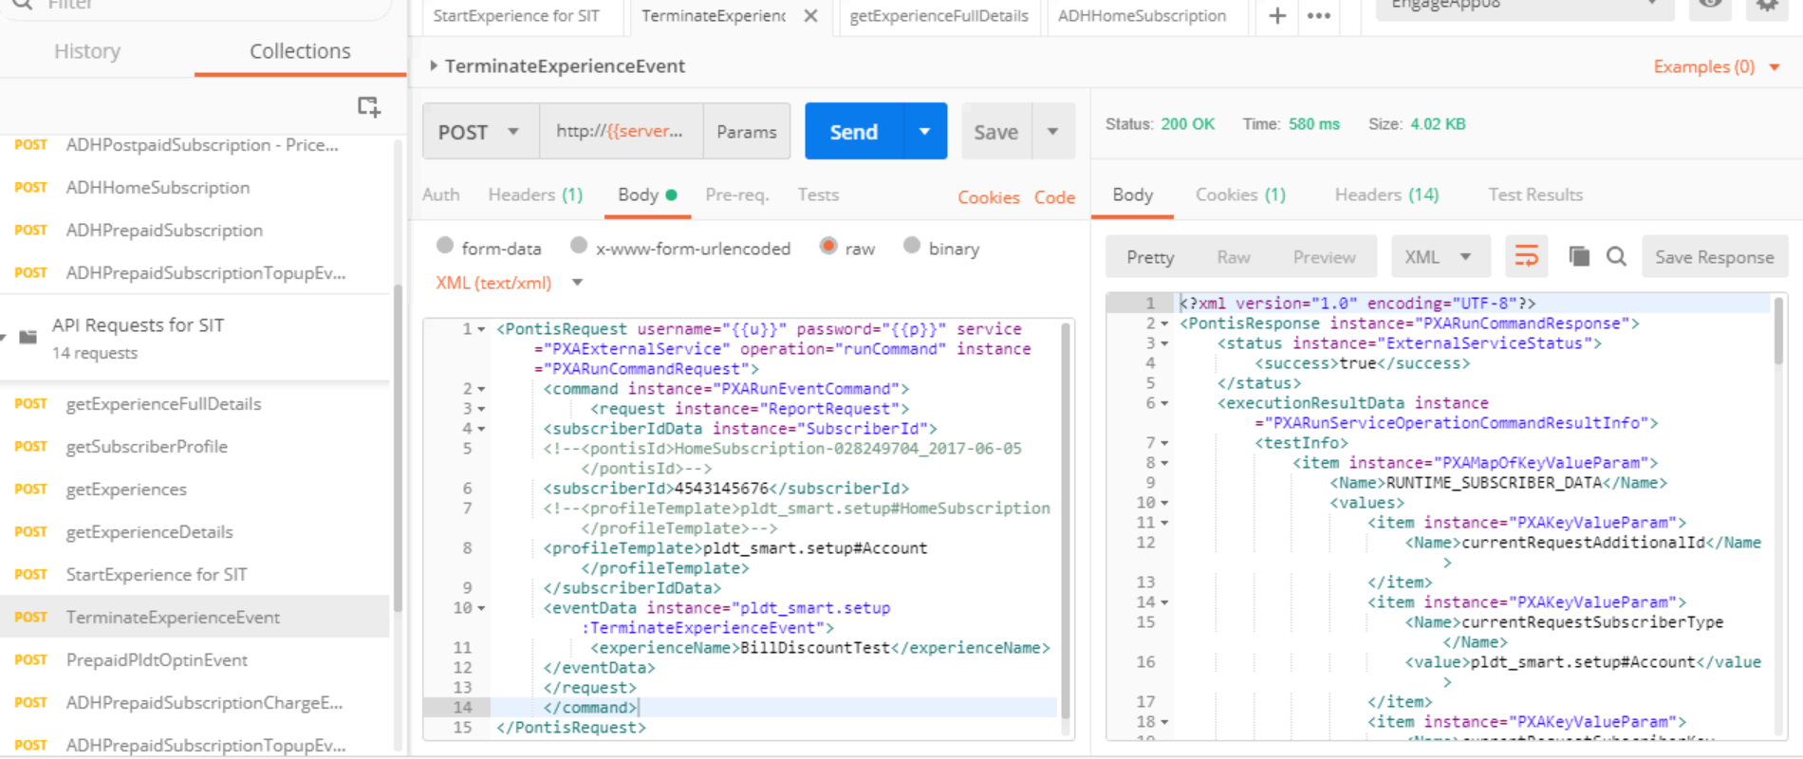

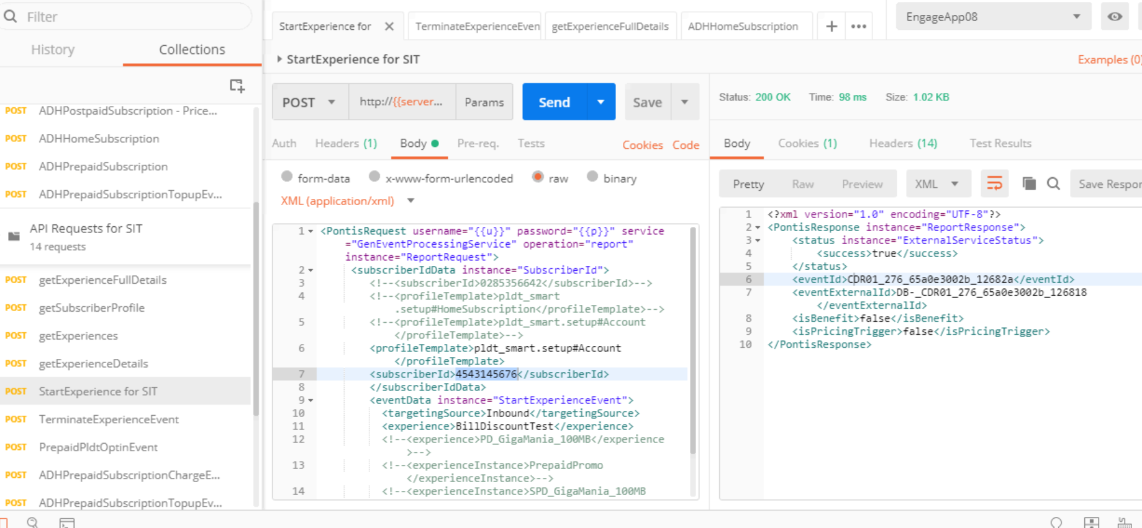

**01 GET EXPERIENCE FULL DETAILS :**

**Verify Subscribers enters into the camapaign successfully:**

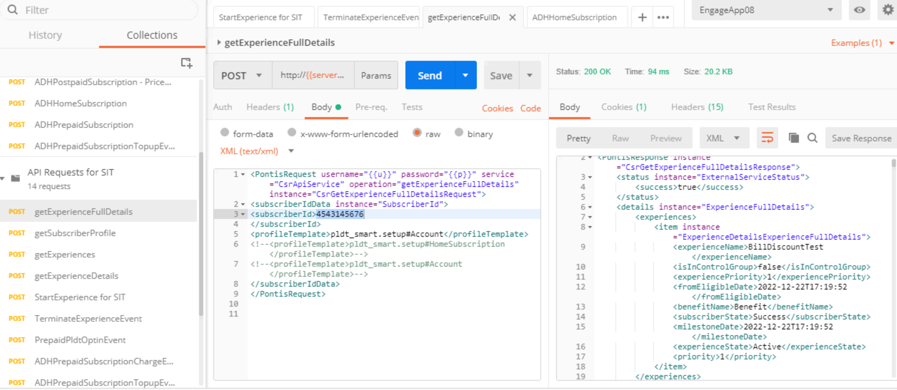

**02 .Verify Request file is generated :**

1.File Name Convention should be in the format of BILL_DISCOUNT_001_<TIMESTAMP>.txt

2.Verify whether file contains all the attributes

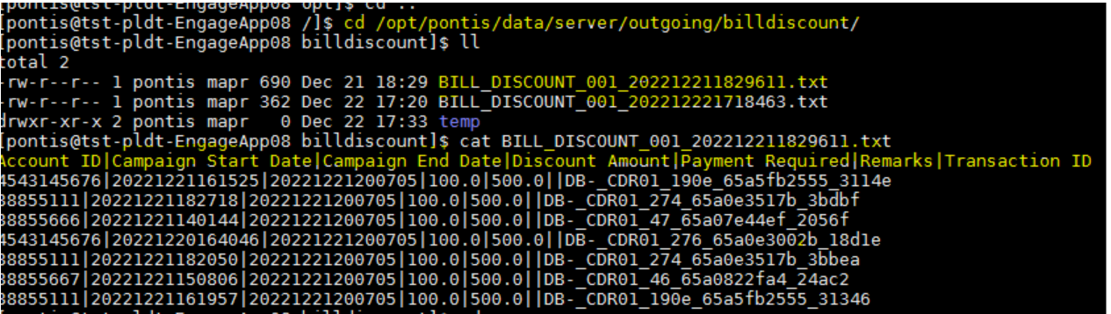

**03. Creation of Response file manually :**

1.Verify whether response file created manually at /opt/pontis/data/server/cdr/incoming/bill_discount/

2.Verify Response file is in the format of BILL_DISCOUNT_RESPONSE_<TIMESTAMP>.txt

3.Verify response file contain 3 attributes.1.Account ID 2.Transaction ID 3.Credit Adjustment Date

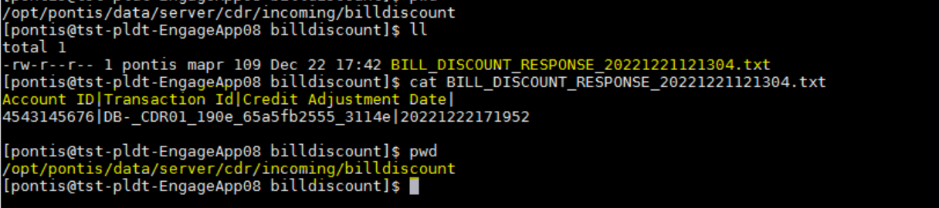

**04 : Trigger the "CDR Events Load from BillDiscountDNCDRFile file" Job**

1.Verify whether responce file process successfully

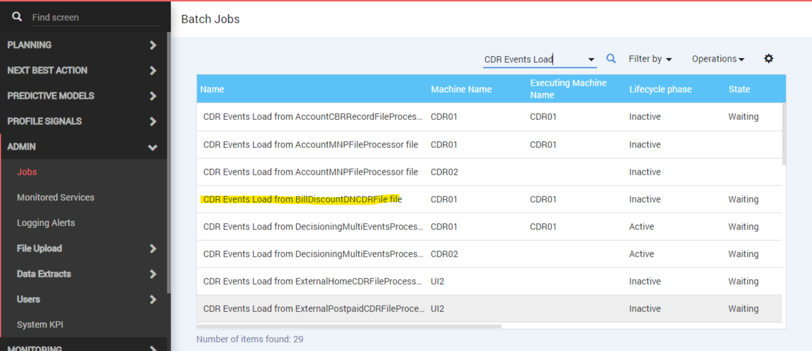

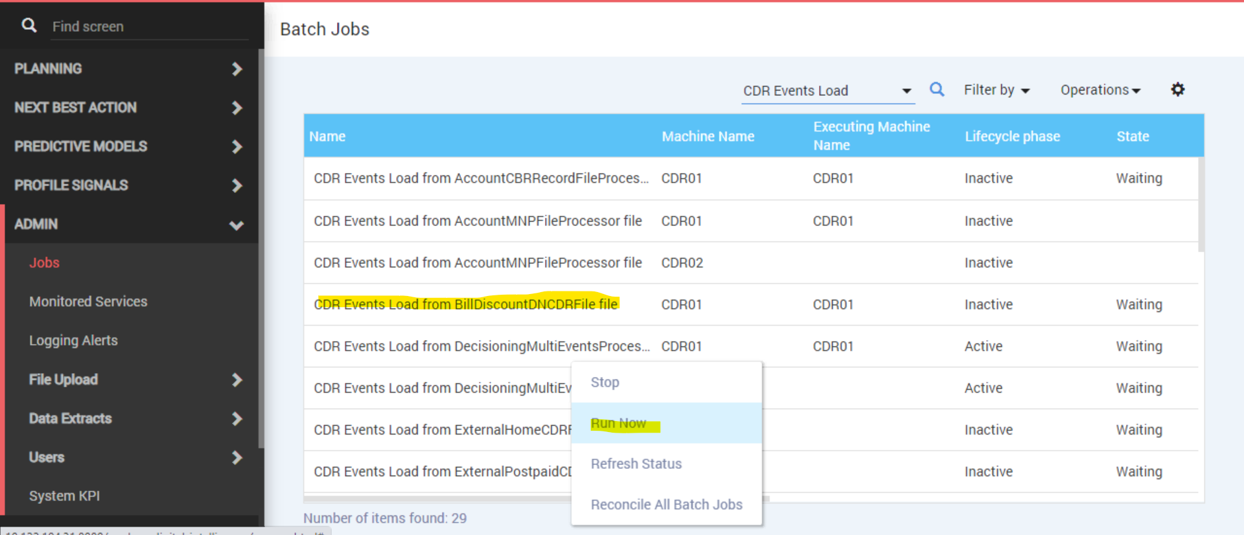

1.Verify whether responce file process successfully

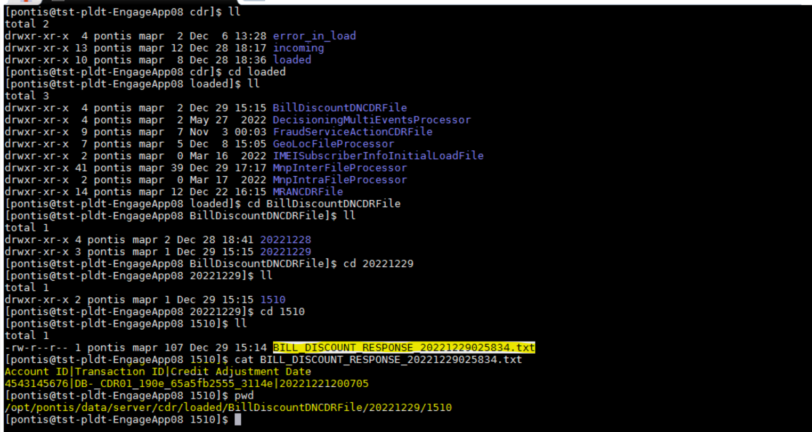

**Verify AccountBillDiscountSuccessEvent Event Generated successfully**

1.verify whether benefit is granted successfully

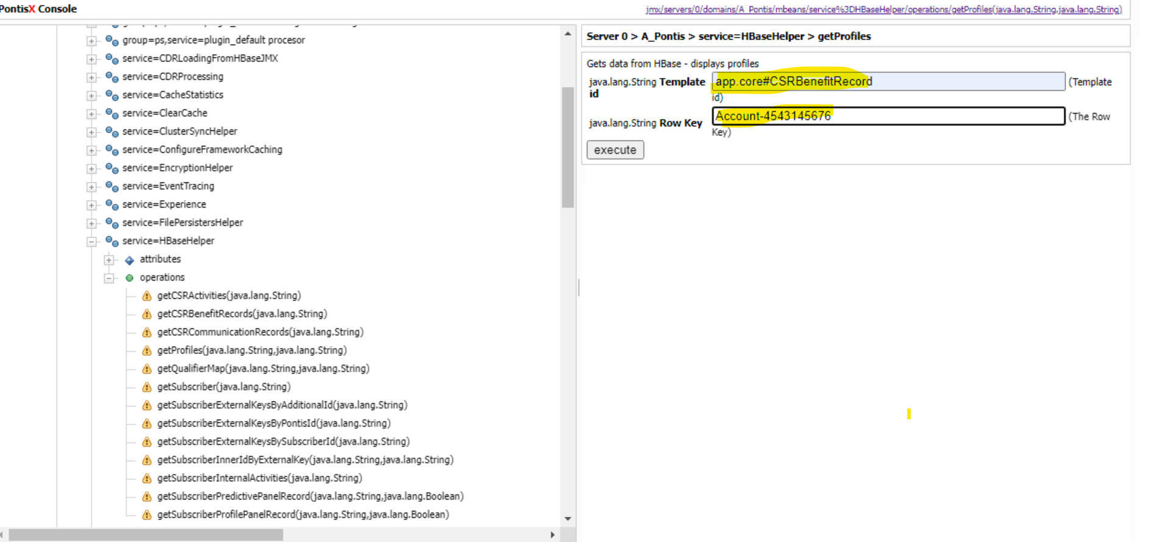

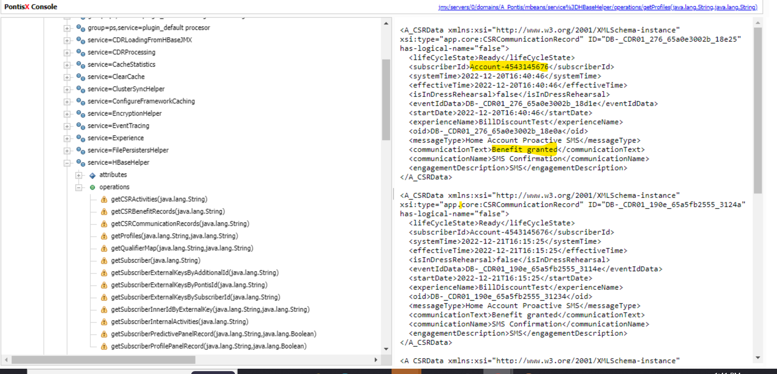

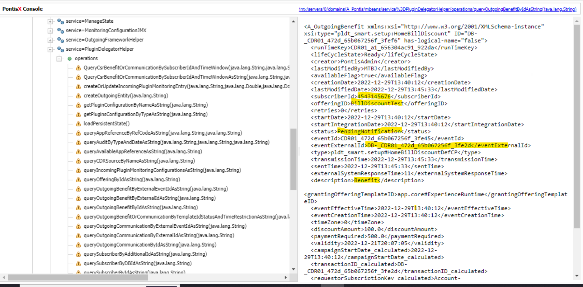

**Run AccountBillDiscountSuccessEvent :**

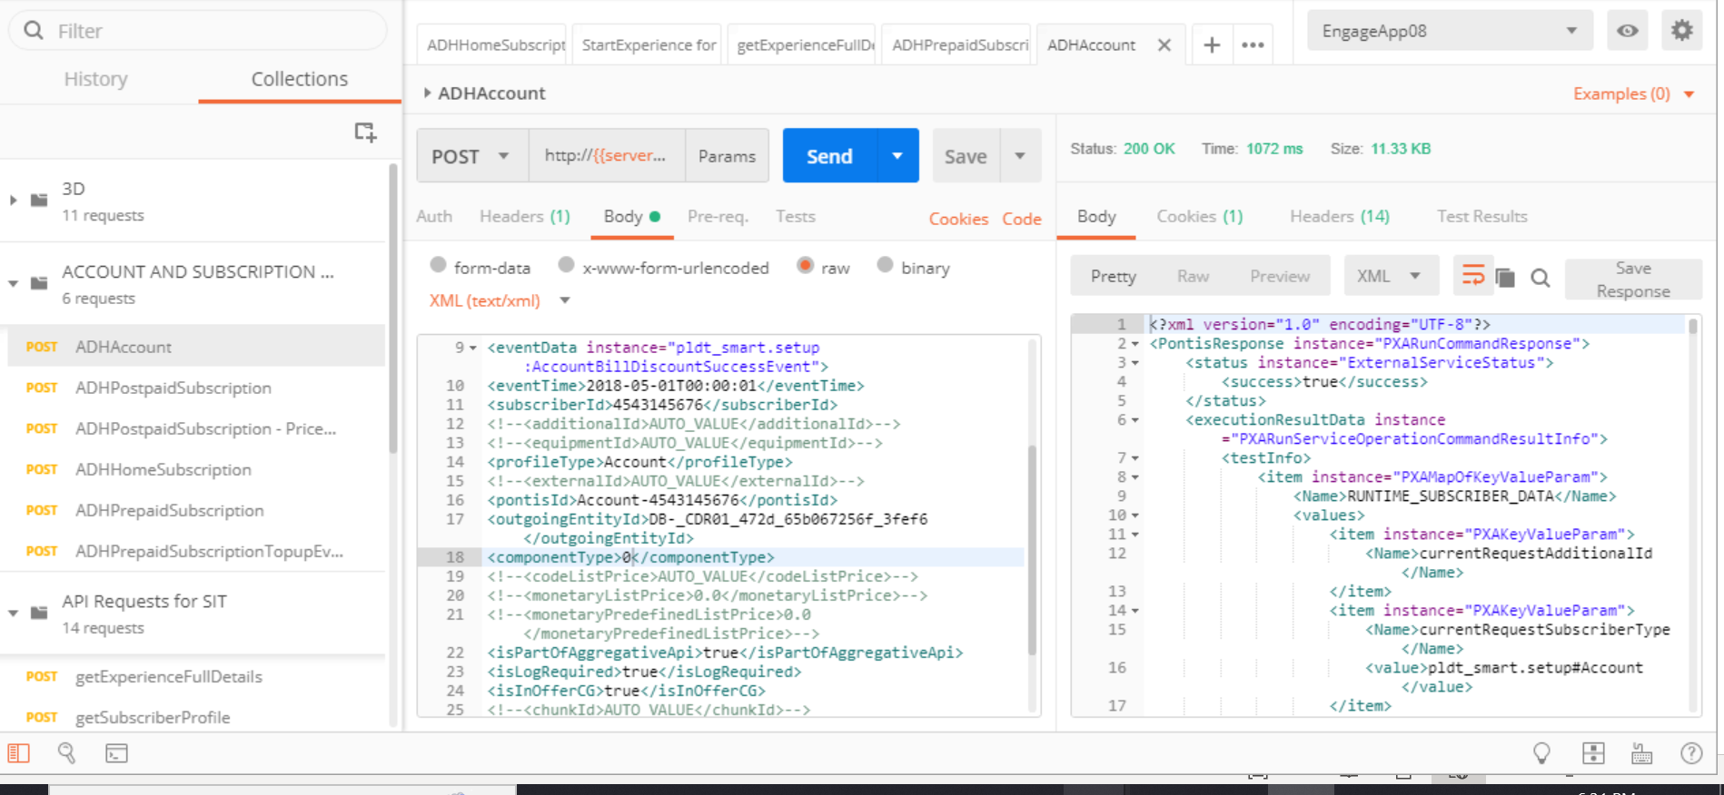

**Verify AccountBillDiscountSuccessEvent Event Generated successfully :**

1.verify whether benefit is granted successfully

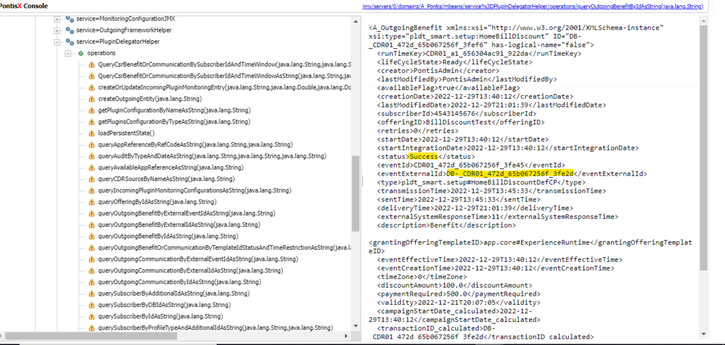

**Verify Start experience event trigger successfully for Profile- Subscriber :**

**\**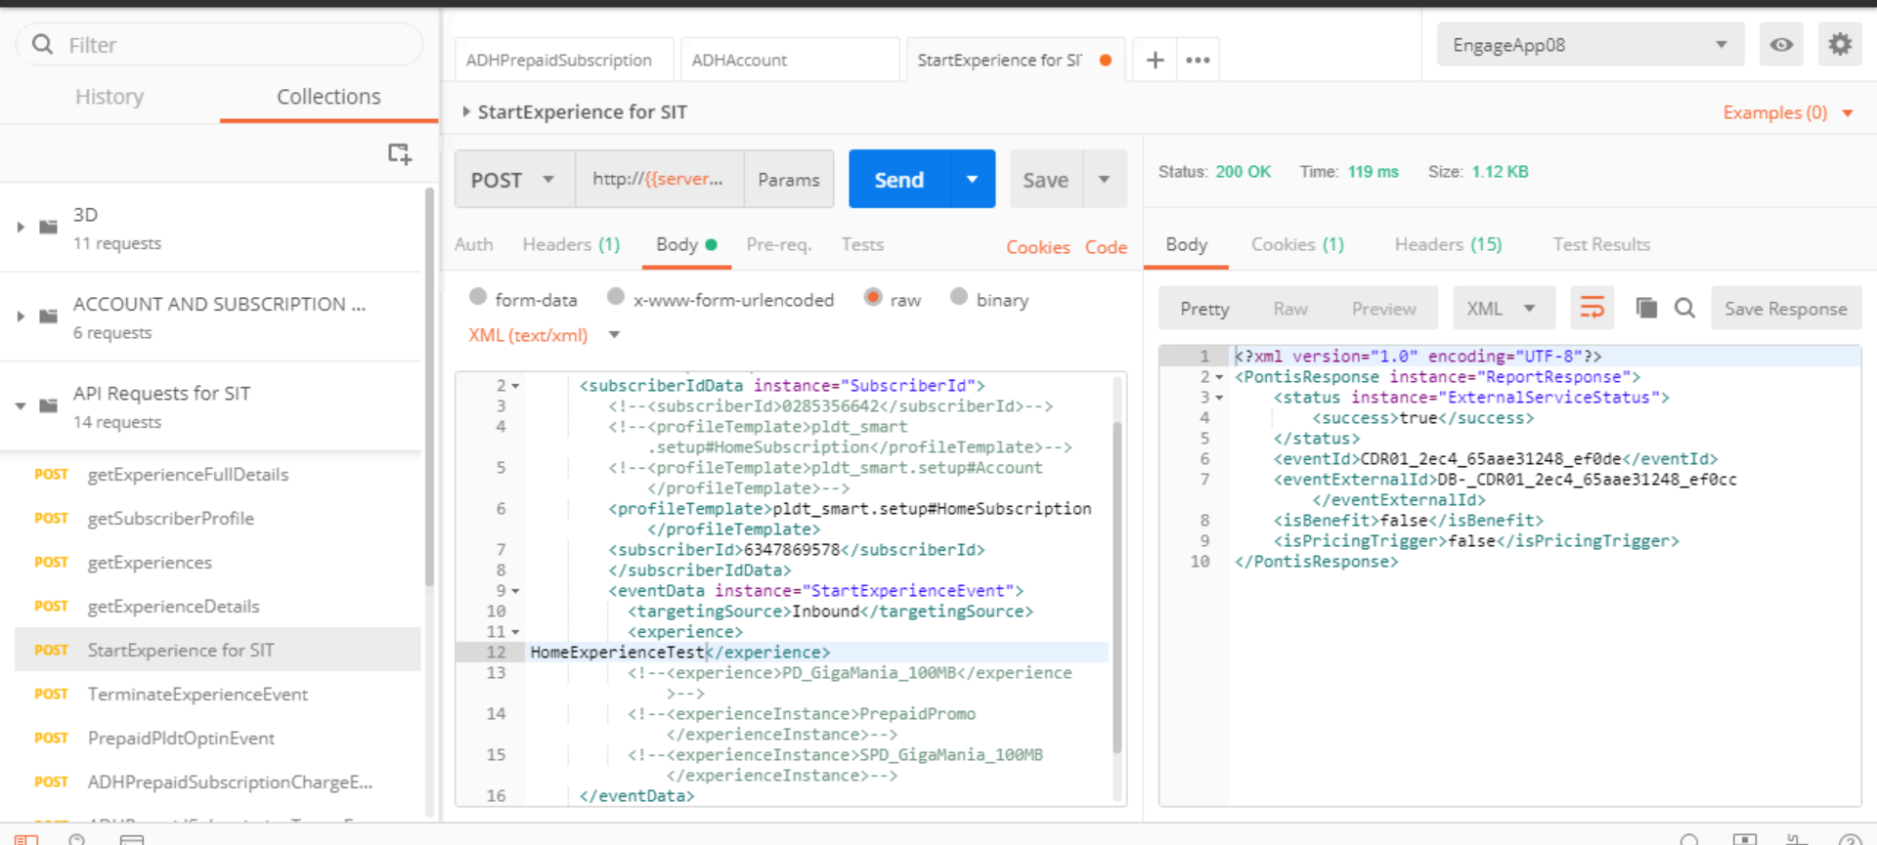

**Verify Bill Discount Request File :**

1.File Name Convention should be in the format of BILL_DISCOUNT_001_<TIMESTAMP>.txt

2.Verify whether file contains all the attributes

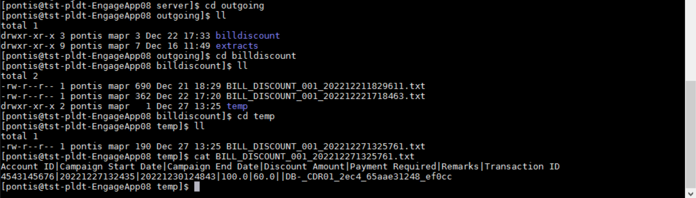

**Creation of Response file manually :**

1.Verify whther response file created manually at /opt/pontis/data/server/cdr/incoming/bill_discount/

2.Verify Response file is in the format of BILL_DISCOUNT_RESPONSE_<TIMESTAMP>.txt

3.Verify response file contain 3 attributes.1.Account ID 2.Transaction ID 3.Credit Adjustment Date

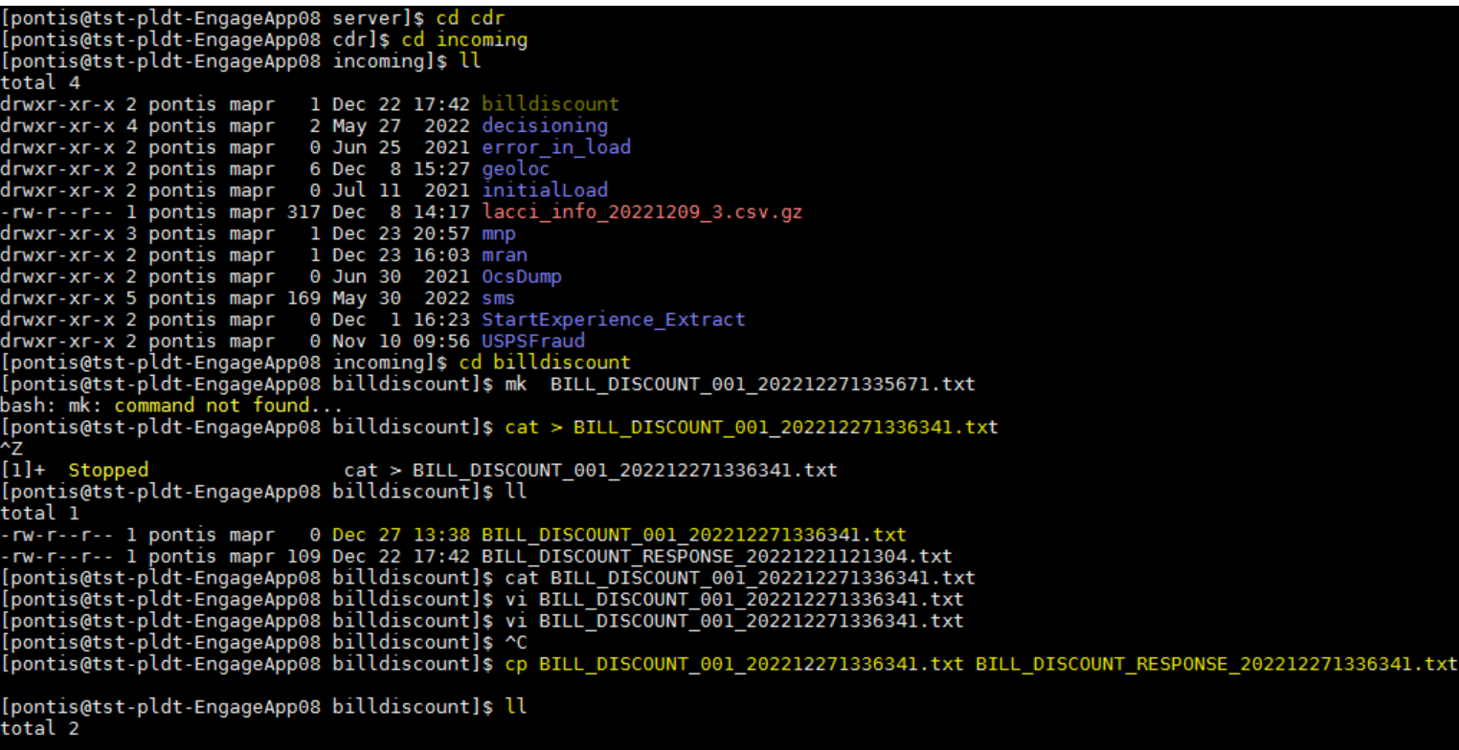

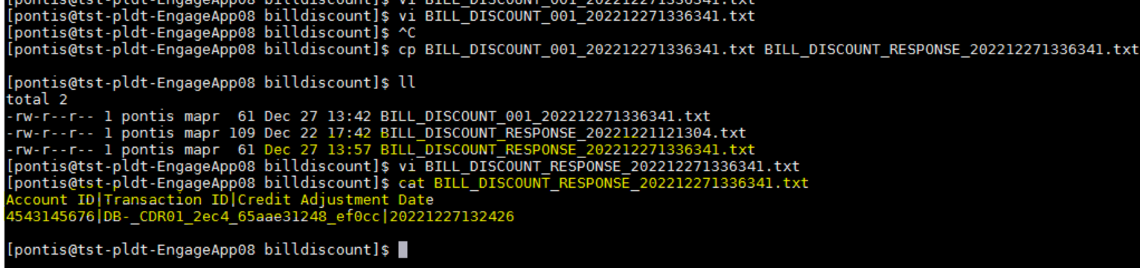

**FOR HOMESUBSCRIPTION : (Benefit Granted)**

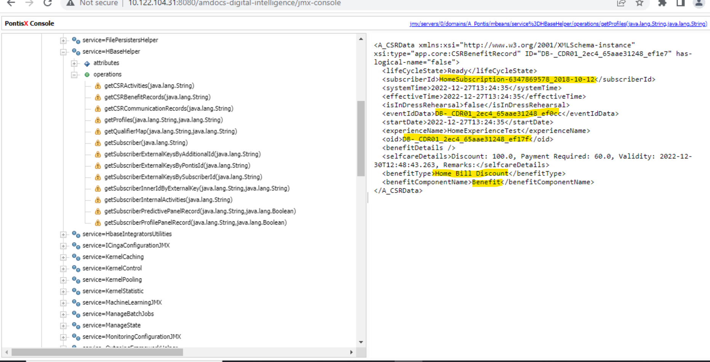

**Trigger the "CDR Events Load from BillDiscountDNCDRFile file" Job :**





**Home Subscription:**

**Get oid from get profiles and check in queryoutgoingbenefitbyids string:**

